The objective of this project is to build and validate a repeatable forensic workflow for acquiring and analyzing volatile memory from a live Steam session in Windows, and then automatically extracting high-value artifacts such as Steam account/profile data, friends information, live chat content, timestamps, and browsing / activity traces. The long-term deliverables include (1) a working acquisition pipeline with hashing and evidence organization, (2) automated artifact carving logic that can recover Steam evidence directly from memory, and (3) an eventual Volatility 3 plugin that can output structured results like chat logs, SteamIDs, and URLs for an investigator. The scope of analysis for this report includes Scenarios A, B, and C (Steam account/friends, Steam chat, and library/store usage). Scenario D (workshop / cart activity) and final plugin polish are upcoming work.

The first stage of work was environment setup, tooling, and acquisition. I built a controlled Windows 11 virtual machine, installed Steam, and confirmed that I could log in and use Steam normally. I then tested live memory acquisition tools, specifically DumpIt (and also WinPMEM as an alternative). Using DumpIt, I was able to capture full physical memory while Steam was active. The DumpIt acquisition output shows the OS version, physical memory size (~4 GB in this VM), and an acquisition timestamp. It also confirms where the memory image was written. After each capture, I immediately calculated a SHA256 hash of the dump and stored that hash in a parallel hashes folder for that scenario, which preserves forensic integrity and gives me a chain-of-custody style record. 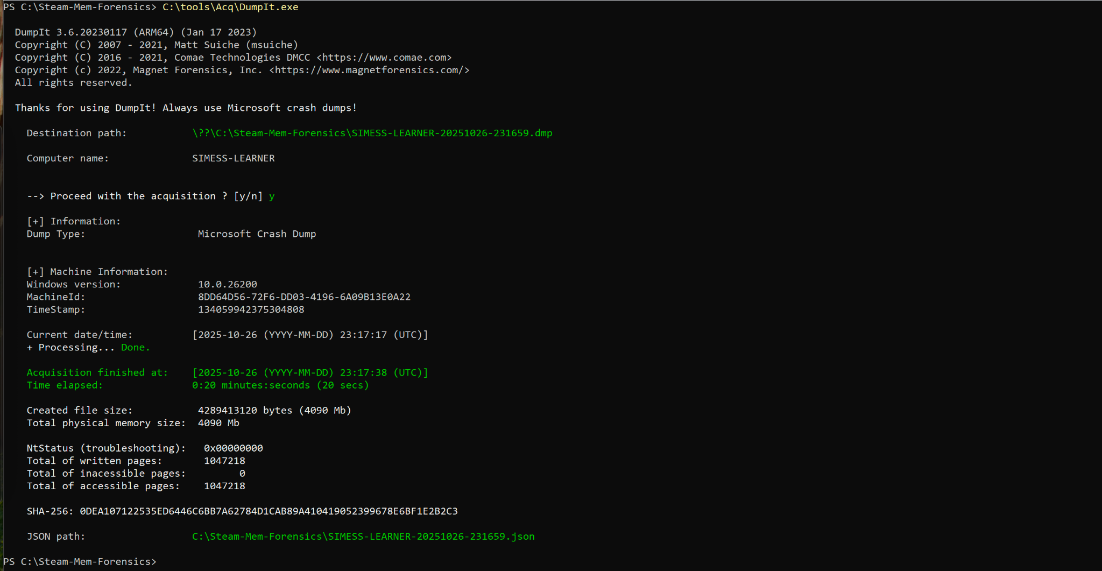 I standardized the output folder layout under C:\Steam-Mem-Forensics\ so that each scenario (scenarioA_friends, scenarioB_chat, scenarioC_store_active, etc.) has its own 20_acq\<scenario>\images\ folder for the raw .dmp file, a 20_acq\<scenario>\hashes\ folder for the SHA256, and a 30_analysis\<scenario>\ folder for carved text/CSVs. I also wrote PowerShell to automate this process: create those folders, find the newest dump, move/rename it to a meaningful filename (for example B0_chat_active.dmp), hash it, and confirm the file size with Get-Item.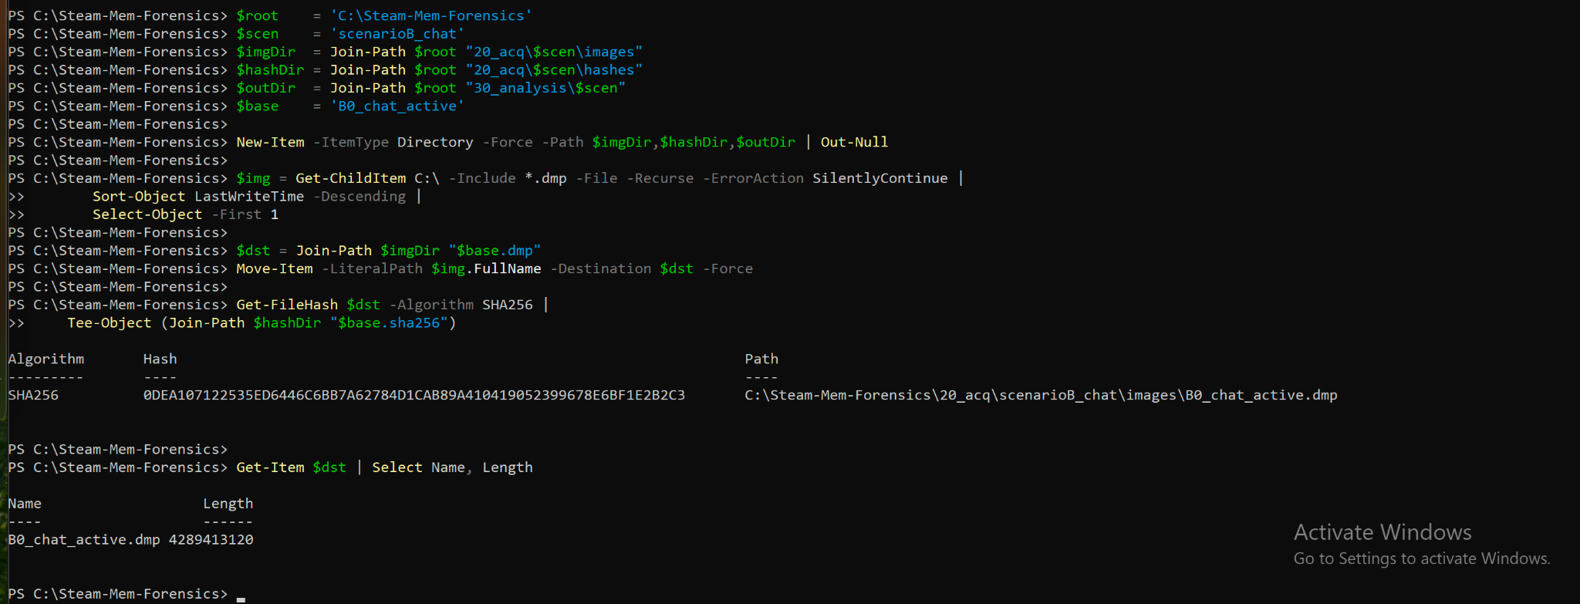

Once acquisition was reliable, I moved on to actually pulling evidence out of memory. I installed Sysinternals strings64.exe and scripted two passes for each dump: one for ASCII strings and one for UTF-16LE (“Unicode”) strings using -accepteula -n 6 (minimum length 6, no banner) and -u for the Unicode pass. For each scenario dump, the script writes two big text files to that scenario’s 30_analysis folder, e.g. B0_chat_active_ascii.txt and B0_chat_active_unicode.txt. I verified these were large (tens to hundreds of MB), which means we are successfully carving human-readable material out of RAM and preserving it as an artifact. 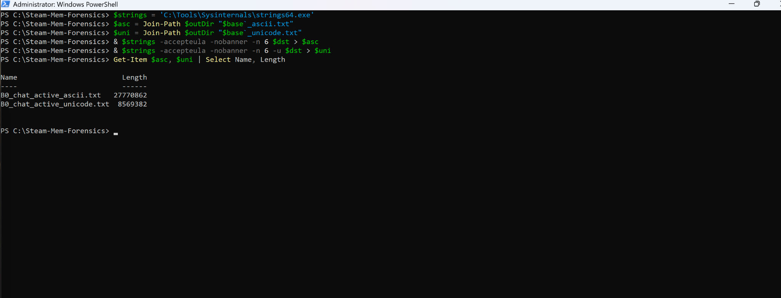

With that extraction pipeline in place, I started stepping through the scenarios defined in the project plan. Scenario A (Week 2 goal) focuses on account, profile, and friends. For this, I logged in, viewed/edited the profile, and added/removed a friend, then captured memory while Steam was running (“idle with Steam open”). The goal here was to prove that Steam profile data and social graph references are resident in memory. Volatility 3 was installed and I attempted to run core Windows plugins (like windows.pslist) on the Scenario A memory image to identify Steam-related processes such as steam.exe and steamwebhelper.exe. Volatility ran, but on this Windows 11 ARM64 VM it failed symbol resolution and translation layer requirements, giving errors like “Unsatisfied requirement plugins.PsList.kernel.layer_name” and “A translation layer requirement was not fulfilled.”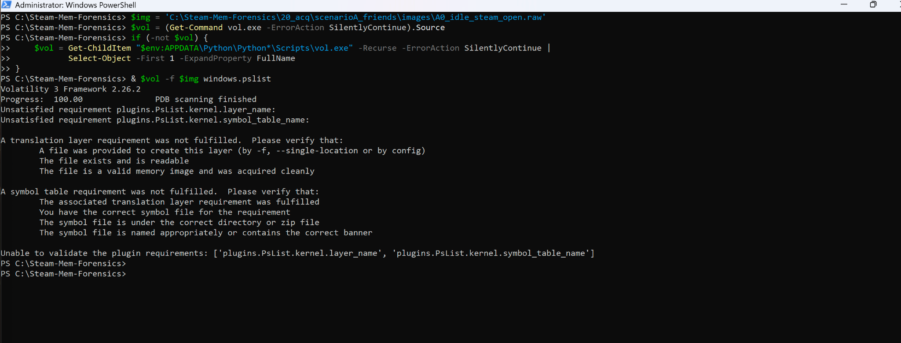This tells me Volatility is present and callable, but auto-detection of the profile for ARM64 memory isn’t solved yet. Because of that, I pivoted to direct carving instead of relying on Volatility to walk memory structures.

For Scenario A, I wrote PowerShell helpers to run regex searches over the carved string dumps and pull Steam-relevant indicators. One function, Extract-Matches, wraps Select-String and extracts regex group values. I used it to find things like Steam profile URLs (https://steamcommunity.com/profiles/<steamID64> and https://steamcommunity.com/id/<vanityName>), Steam store app URLs (https://store.steampowered.com/app/<appid>/<slug>), and 17-digit SteamID64 values that start with 7656119. The script converted these matches into structured objects and wrote them out to scenario CSV files such as A0_profiles.csv and A0_apps.csv, and also to supporting text files (A0_urls.txt, A0_steamids.txt). 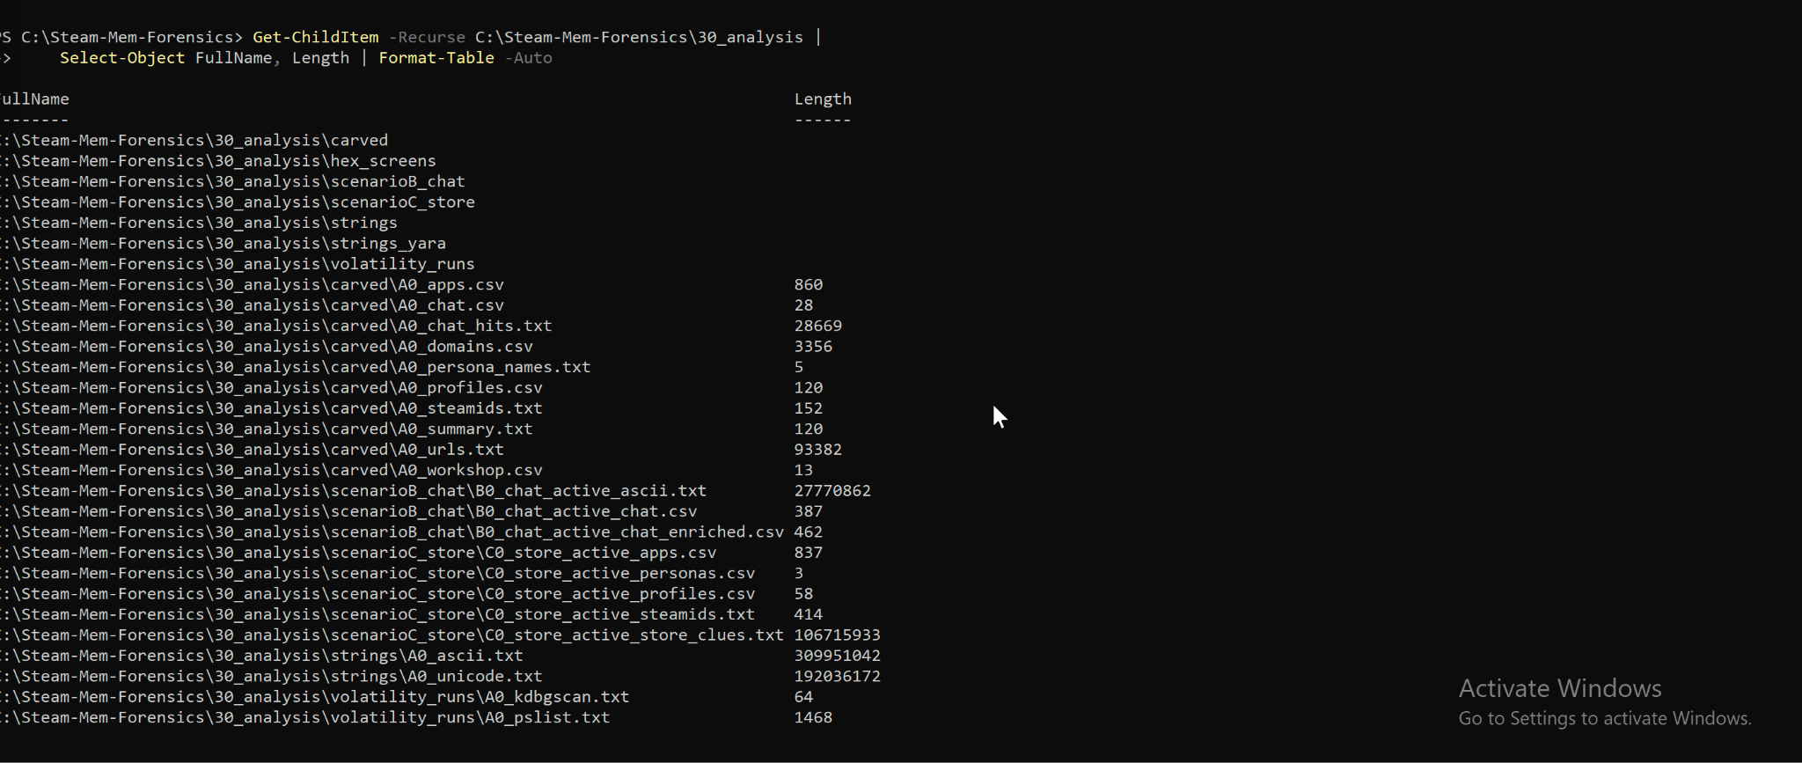 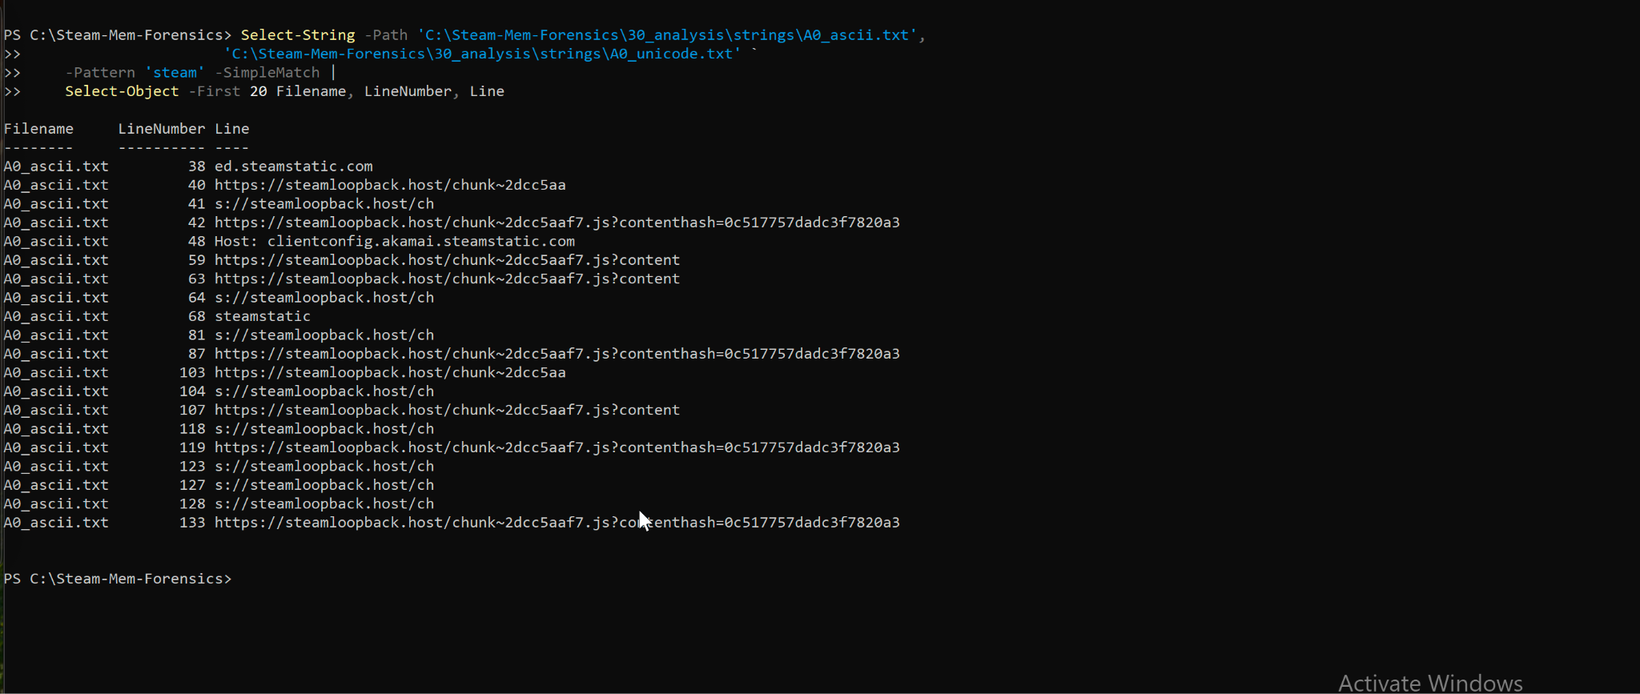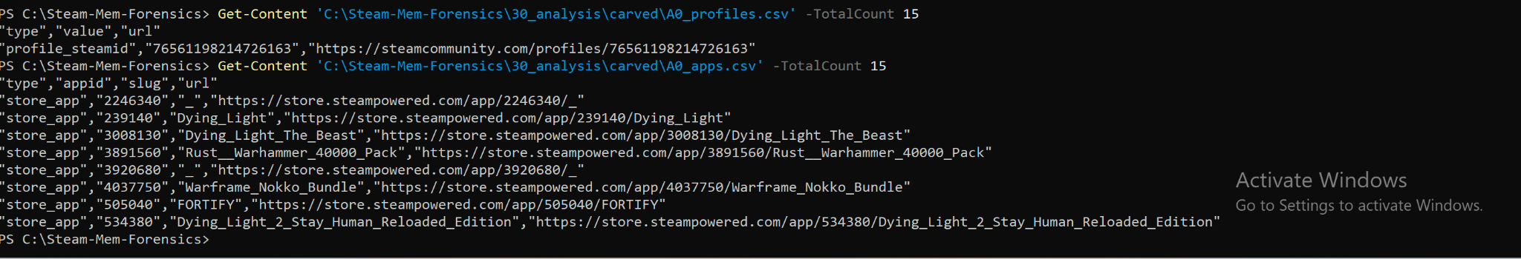We confirmed those CSVs weren’t empty: for example, A0_apps.csv captured app IDs and slugs from Steam store URLs in memory, and A0_profiles.csv captured both numeric SteamIDs and vanity profile names that were present while I had the profile/friends UI open. That means Scenario A is successful: I can acquire memory while Steam is running, and then extract profile/friend-related artifacts (SteamIDs, vanity names, friend/profile URLs, and app IDs) from raw RAM.

Scenario B (Week 3 goal) focuses on Steam chat, which is one of the major high-value artifacts for investigations. I opened a live Steam chat session, exchanged messages (including identifiable phrases like “im going to use our chat for a school project,” “im taking memory dumps…,” and test markers like “A_TAG_2310 three SUPER SECRET KEY”), and then captured RAM mid-chat. I processed that dump the same way (moved it into scenarioB_chat\images\B0_chat_active.dmp, hashed it, dumped ASCII and Unicode strings to B0_chat_active_ascii.txt and B0_chat_active_unicode.txt). I then wrote a chat carving routine. The idea was to regex for small JSON-like fragments in memory that looked like "steamid": "...", "timestamp": "...", "message": "...". I used Select-String over both ASCII and Unicode strings with a pattern that tried to pull out three things: the sender SteamID (7656119...), a UNIX-style timestamp, and the message text. For each match, I built a [ps custom object] record with steamid, unix_ts, and message.

Those objects were then sorted/deduped and written to B0_chat_active_chat.csv. When I previewed that CSV, it contained the actual chat content I typed during the Scenario B session, including lines like “im going to use our chat for a school project,” “im taking memory dumps to see if i can uncover chat logs thru a memory dumb,” “if you see weird things jsut ignore htem,” and the test string with A_TAG_2310.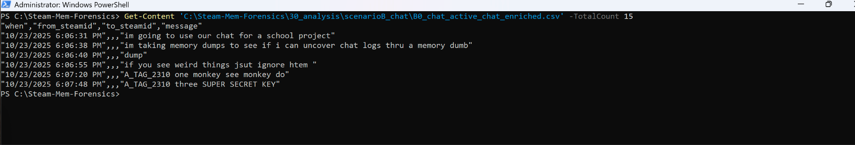This is a major milestone: it proves that (1) Steam chat messages persist in memory in a way that is directly recoverable from a post-acquisition dump, and (2) my automated script can recover them and output them cleanly as CSV. I also expanded this logic by looking for persona/display names in memory ("persona_name":"...") and tried to associate those names and SteamIDs with the chat messages. I then reformatted the recovered chat into a table with columns like when (human-readable timestamp), from_steamid, from_name, to_steamid, to_name, and message. The output shows each message, in order, with approximate human-readable send times like 10/23/2025 6:06:31 PM and so on. That means we are not only grabbing raw chat text, but also beginning to attribute who said what and when, which is critical in an investigation workflow.

Scenario C (Week 3 / Week 4 start) looks at Steam’s store/library activity and general Steam helper behavior. The Steam client (and especially steamwebhelper.exe) is basically an embedded Chromium instance that hits a bunch of Steam, Valve, and Steam CDN endpoints. In Scenario C, I browsed store/library content and launched games. I then captured memory in that “active browsing / active library” state. I ran the same extraction steps (strings, ASCII/Unicode dumps), but this time focused on URLs. I defined multiple URL regex patterns, including https?://store\.steampowered\.com/\S+, https?://steamcommunity\.com/\S+, and a generic catch-all like https?://[^ \t\r\n"]*steam[^ \t\r\n"]+ to capture things like steamloopback.host, steamstatic, steambroadcast, and so on. I looped over those patterns, gathered all matches from both the ASCII and Unicode strings files, deduped them, and wrote them into a scenario-specific output file (e.g. C0_store_active_urls.txt). The resulting file includes store URLs, community URLs, local loopback service URLs that Steam uses internally, CDN links for assets, and even cached library paths like C:\Program Files (x86)\Steam\appcache\librarycache\.... That gives us evidence about which games/pages the user had browsed or launched, what assets were loaded, and generally what the user was doing in Steam at the time of capture.

At this point (the 50% mark), Scenarios A, B, and C have all been run and at least partially analyzed. We’ve proven that we can (1) acquire memory, (2) hash and organize it in a repeatable way, and (3) carve meaningful Steam artifacts out of it using our PowerShell + regex pipeline. We have structured CSV/text outputs for profile/friend data and IDs (Scenario A), chat logs with timestamps and message content (Scenario B), and store/library URLs plus app/game info (Scenario C). We also confirmed that the memory captures contain Steam process content from steamwebhelper.exe and Steam’s embedded Chromium environment, which is where most of the rich artifacts we recovered actually live. 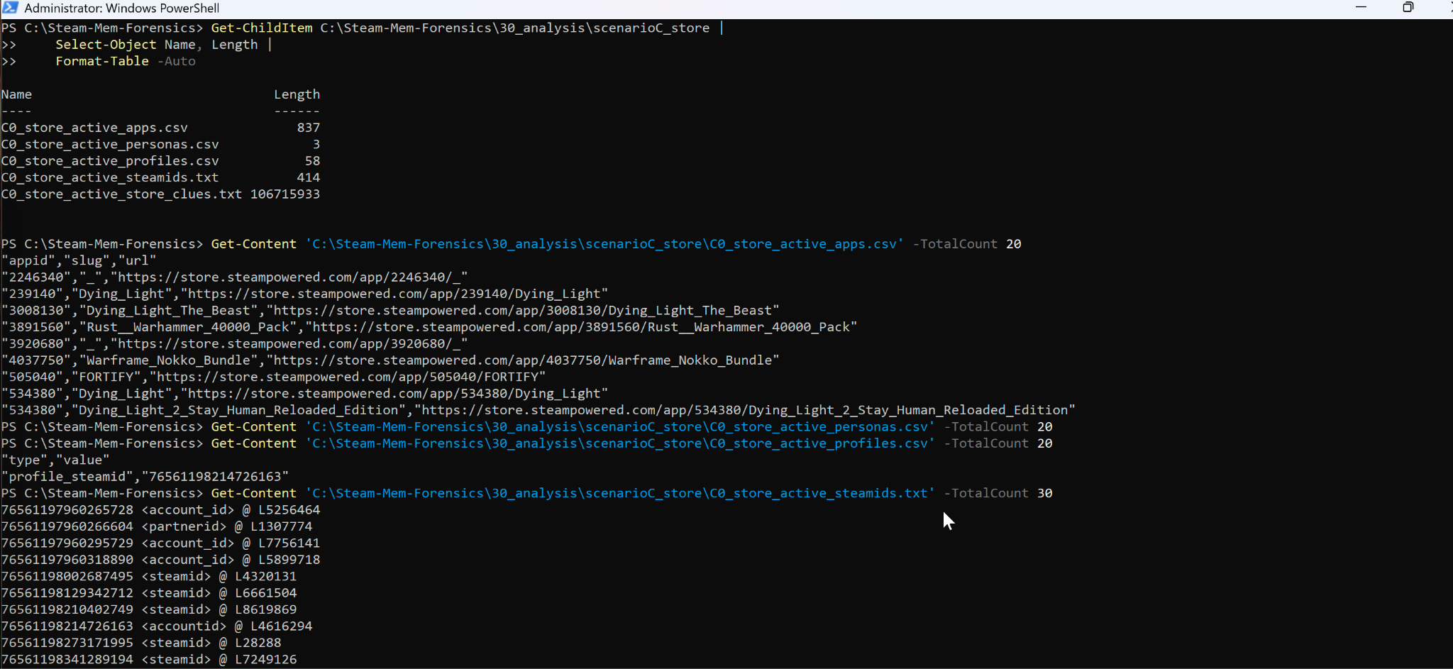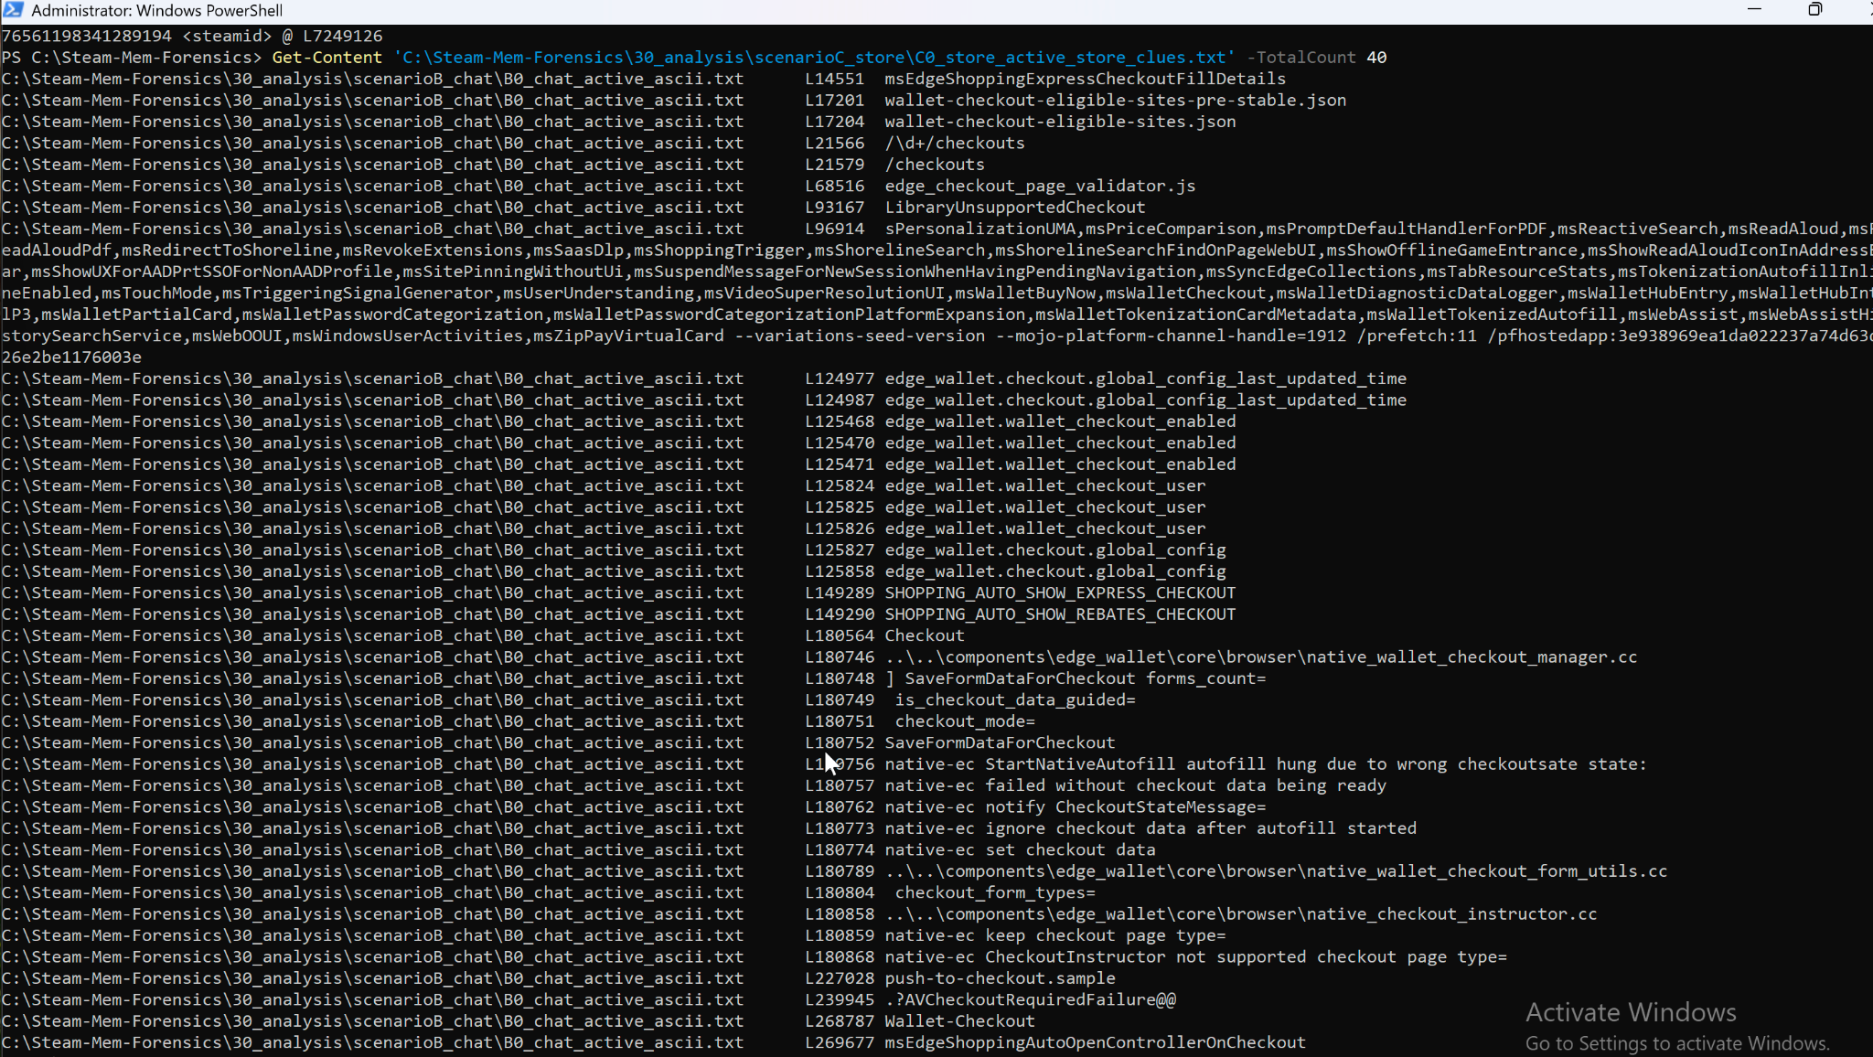

Now, the remaining work is mostly about integration, polishing, and coverage. First, Volatility 3 integration: right now, Volatility 3 is installed and callable, but it cannot currently resolve symbols or build a translation layer for my Windows 11 ARM64 dump. Because Volatility’s Windows plugins (like pslist) rely on valid kernel layer + symbols, they error out instead of enumerating processes. The original project plan expected a custom Volatility plugin by this checkpoint. Functionally, I have the logic, I can already extract chat, SteamIDs, and URLs, but that logic currently runs as PowerShell post-processing on the strings64.exe output instead of running inside a Volatility plugin. My next step is to bridge that gap. I have two options: (1) build or supply an ARM64 profile / layer to Volatility so it can parse my current dumps, or (2) redo captures on an x86_64 Windows VM (which Volatility supports much more smoothly) and then port my regex extractors into a proper Volatility 3 plugin class that walks process memory regions for steam.exe / steamwebhelper.exe and emits CSV. This Volatility integration and “plugin 0.5” packaging is scheduled for the next phase. 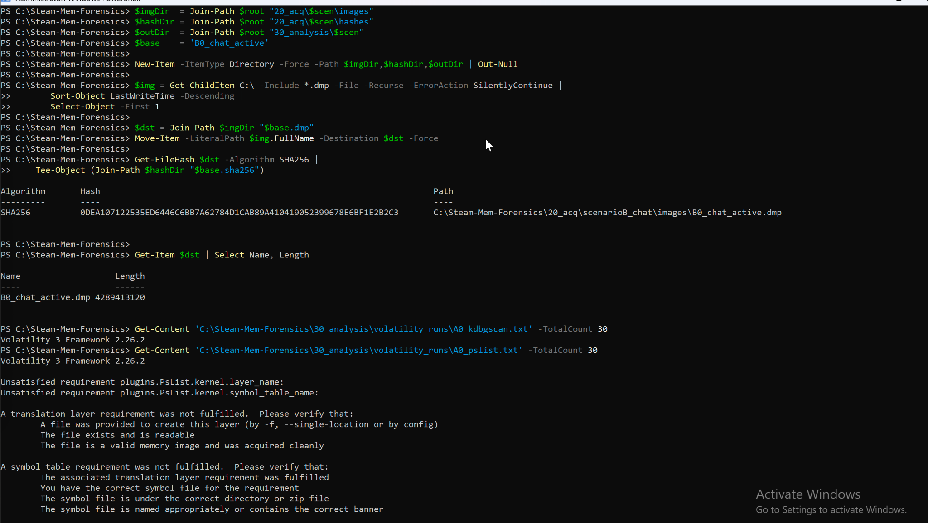

Second, I have not yet run Scenario D (store browsing + workshop + cart without purchasing). Scenario D will matter because it should surface evidence like “user viewed this item / subscribed to this workshop mod / added this to cart,” which is extremely relevant to intent and capability questions in an investigation. That scenario is on deck next, but per instructions we’re ignoring Scenario D for this checkpoint. Third, I still need to normalize timestamps, clean up identities, and export investigator-friendly formats. Right now the chat CSV includes raw unix_ts values; I’ve demonstrated I can convert those into human-readable timestamps and even map persona names to messages, but this process should be baked into the automated pipeline so every row comes out with “when,” “who,” and “what” in a single pass instead of doing final formatting by hand. Finally, I will need to capture screenshots, produce short demonstration snippets, and draft the slides and short demo video for the final deliverables.

In terms of schedule: by the end of Week 1 and Week 2, I accomplished environment setup, Steam install, acquisition tooling, baseline captures, and Scenario A memory carving for profile/friend data. By the end of Week 3, I ran Scenario B (chat), recovered live chat content from memory, and began Scenario C (store/library/launch), extracting URLs and app IDs from Steam’s helper processes. By now (around the Week 4 checkpoint), I have working automated scripts that generate CSVs for at least three artifact classes: (1) Steam account/profile info and SteamIDs, (2) Steam chat logs with timestamps and message text, and (3) Steam store/library URLs and activity traces. That meets the “50% complete” bar because we have acquisition, we have extraction, and we have proof-of-artifacts for multiple scenarios. The remaining big tasks are: fixing Volatility integration so this logic can live in a plugin (planned in the next ~2 weeks), finishing Scenario D (store/workshop/cart browsing evidence), and then polishing output formats (timestamps and identities), documentation, screenshots, and demo materials for the final report and video.

